Aaron Owens

Interview Questions

2/12/19

Interview 1

Q1-How much bandwidth will you need for each of the six locations? (Upper and lower limit of frequency)

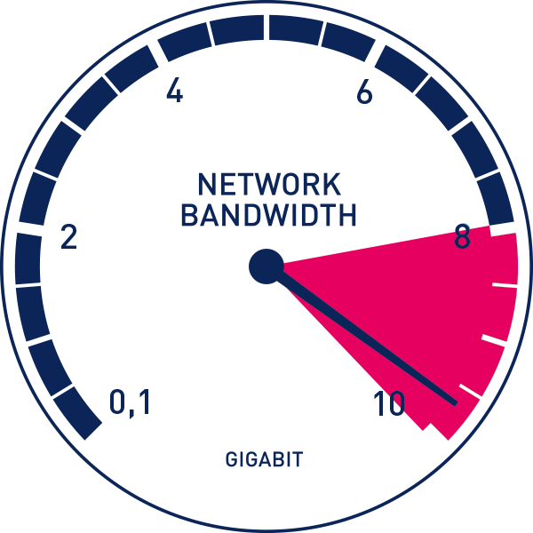

Q2-How many networks will be in your new Topology? (Physical layout of the computer network)

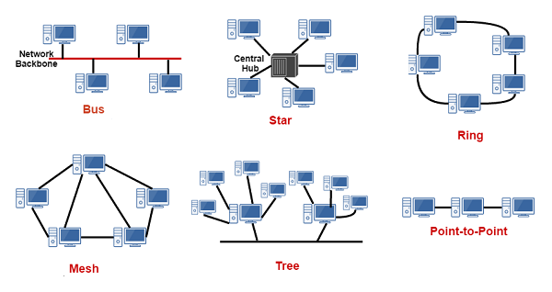

Q3-What’s your plans to upgrade routers and switches?

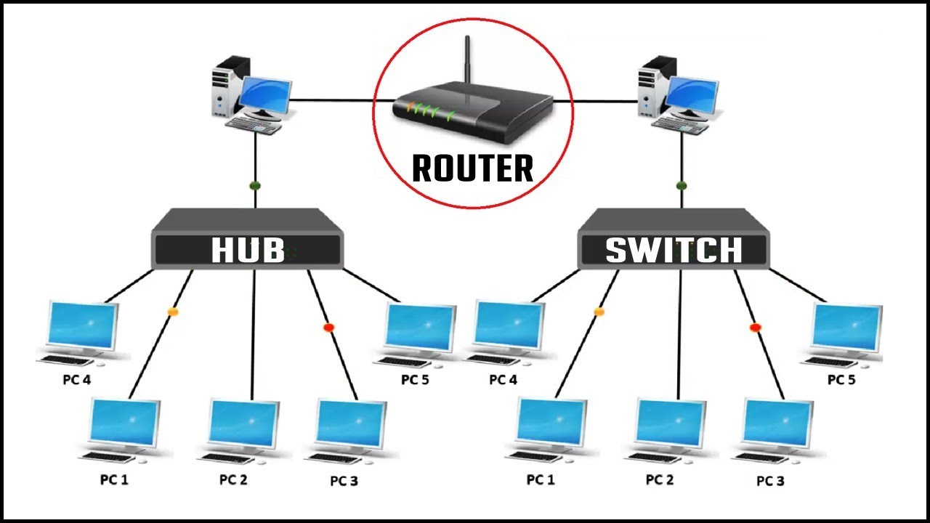

Q4-Do you have plans to upgrade your NIC for each new device? (Network Adapter)

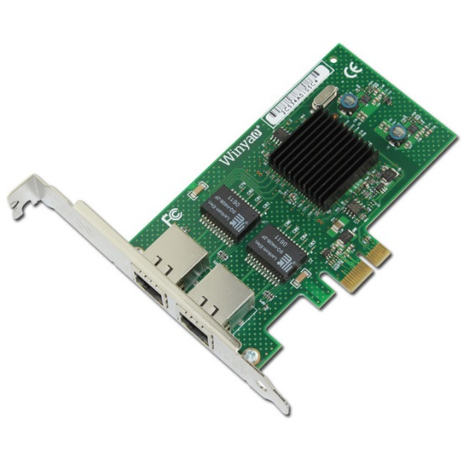

Q5-What is your budget to upgrade VPNs for each location? (Virtual Private Network)



Q6-Are you planning on switching out every Hub for a router for each location? (Hub least expensive, least intelligent,)

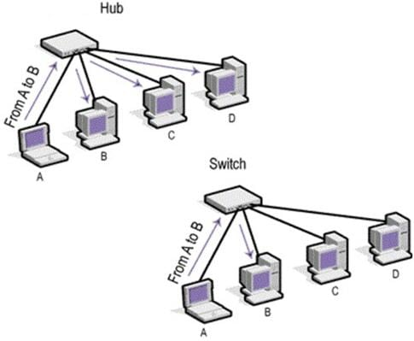

Q7- Tell me about your plans to go from multiplexing to multi-accessing?

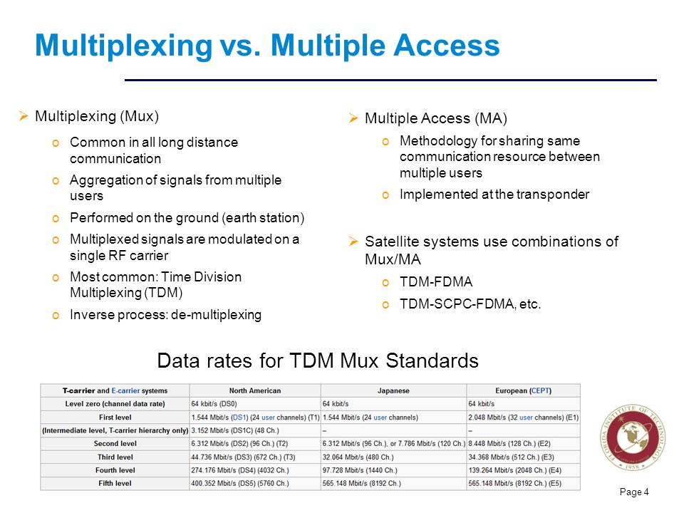

Q8-What are your plans to make the new network more effective and efficient?

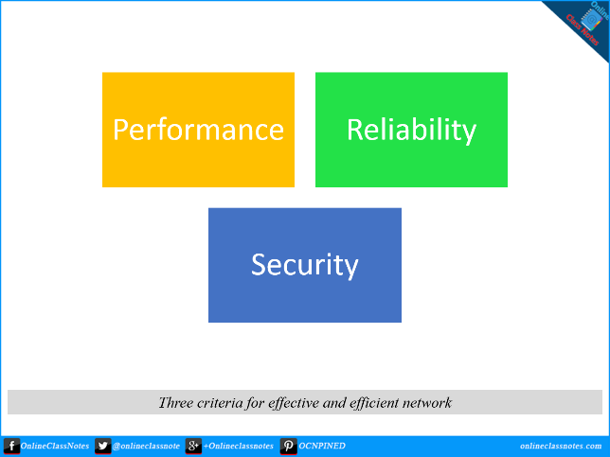

Q9- What are the 3 major protocols you will be using for your new network?

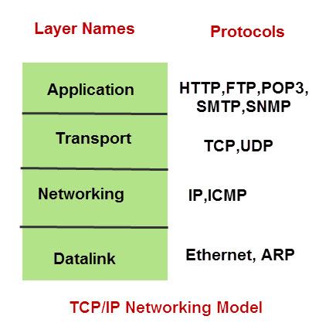

Q10- What is the difference between firewall & anti-virus? (Explain)

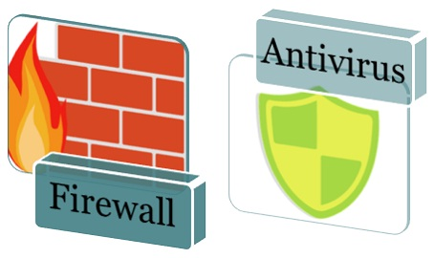

Q11- Give me a detailed explanation of your goals for the new network?

